EDA – SQL Questions and Answers
This is an example of how to answer a question and include the sql code. Please make your answers clear and concise. A mono-spaced font will make your code clear and easy to read.
Q1. How many rows are in each table?
A: Table accounts 42
Code:
SELECT
COUNT(*)
FROM
Accounts;
Table orders 6912
Code:
SELECT
COUNT(*)
FROM
Orders;
Table region 4
Code:
SELECT
COUNT(*)
FROM
Region;
Table sales_reps 50
Code:
SELECT
COUNT(*)
FROM
Sales_reps;
Table web_events 9073
Code:
SELECT
COUNT(*)
FROM
Orders;
Q2: What is the date range of orders?
A:
From 2013-12-04 to 2017-01-02
Code:
SELECT
MIN(occurred_at)::date AS first_order_date,
MAX(occurred_at)::date AS last_order_date
FROM orders;
Q3: How many of each type of paper has been sold?
A:
Standard : 1938346; Gloss:1013773; Poster: 723646
Code:
Select sum(orders.standard_qty) as standard_sum,sum(orders.gloss_qty) as gloss_sum,sum(orders.poster_qty) as poster_sum
From orders;
Q4: How much, in dollars, have each of the paper types sold?
A:
Standard : $ 9,672,346.54; Gloss: $7,593,159.77; Poster: $5,876,005.52
Code:
Select sum(orders.standard_amt_usd) as standard_revenue,sum(orders.gloss_amt_usd) as gloss_revenue,sum(orders.poster_amt_usd) as poster_revenue
From orders;
Q5: What is the most profitable paper type?
A: Standard since it has highest revenue. However, profitable should be calcuated by revenue minus cost but I don’t have cost data .
Q6: What are the top five accounts by average total amount?
A:
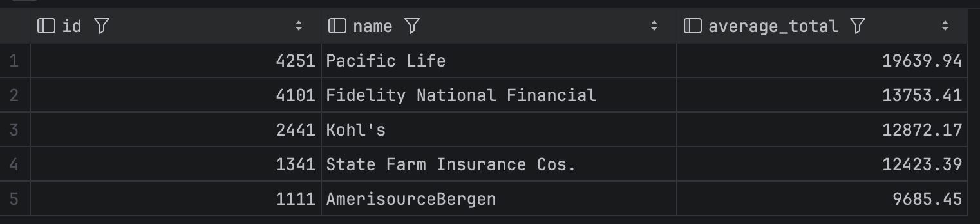
Code:
Select a.id,a.name,round(avg(o.total_amt_usd),2) as average_total
From accounts as a
Join orders as o on a.id = o.account_id
Group by a.id,a.name
Order by average_total desc
Limit 5
Q7: What channel do most of the online sales come from?
A: Direct channel
Code:
Select
Channel, count(*) as total_events
From web_events
Group by channel
Order by total_events desc
Limit 1
Q8: Which region_id has the largest number of sales persons?
A: Region id 1 Northeast total 21 sales persons
Code:
select r.id,r.name as region_name,count(s.id) as total_no_of_sales_rep
from sales_reps s
join region r on s.region_id = r.id
group by (r.id,r.name)
order by total_no_of_sales_rep desc
limit 1
Q9: Which web events channel had the highest total quantity sold of all three types of paper?
A: Direct channel total 3675765
Code:
select w.channel, sum(total) as total_sold
from orders o
join (select distinct web_events.account_id,channel from web_events) w on w.account_id = o.account_id
group by channel
order by total_sold desc
limit 1
Q10: Which region, by name, has the highest amount of sales in USD?
A: Northeast $ 7,744,405.36
Code:
select r.id,r.name as region_name,sum(o.total_amt_usd) as total_sales_usd
from accounts a
join sales_reps s on s.id = a.sales_rep_id
join region r on r.id =s.region_id
join orders o on o.account_id = a.id
group by (r.id,r.name )
order by total_sales_usd desc
limit 1
Q11: Categorize each region’s average sales as “Above Average” or “Below Average” based on the average for the company as a whole.
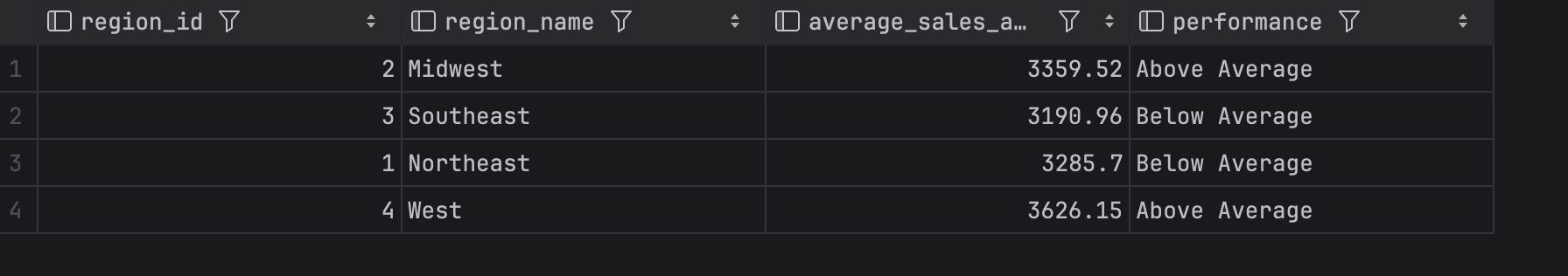
Code:
with average_region as (select r.id as region_id, r.name as region_name, round(avg(o.total_amt_usd), 2) as average_sales_as_region
from accounts a
join sales_reps s on s.id = a.sales_rep_id
join region r on r.id = s.region_id
join orders o on o.account_id = a.id
group by (r.id, r.name))
select region_id,region_name,
average_sales_as_region,
case
when average_sales_as_region > (select round(avg(total_amt_usd), 2) from orders)
then 'Above Average'
else 'Below Average'
end as Performance
from average_region
Q12: What are the total quantities of each paper type sold for the top region?
Code:
with top_sales_region as(select r.id as region_id, r.name as region_name, round(avg(o.total_amt_usd), 2) as average_sales_as_region
from accounts a
join sales_reps s on s.id = a.sales_rep_id
join region r on r.id = s.region_id
join orders o on o.account_id = a.id
group by (r.id, r.name)
order by average_sales_as_region desc
limit 1)
select sum(o.standard_qty) as standard_qty_sum, sum(o.gloss_qty) as gloss_qty_sum,sum(o.poster_qty) as poster_qty_sum
from orders o
join accounts a on a.id =o.account_id
join sales_reps s on s.id =a.sales_rep_id
join region r on r.id = s.region_id
where region_id in (select region_id from top_sales_region)
Q13: What are the average sales in USD by region and sales person? Include region name, sales person’s name, and account name. Include first 20 rows
A:
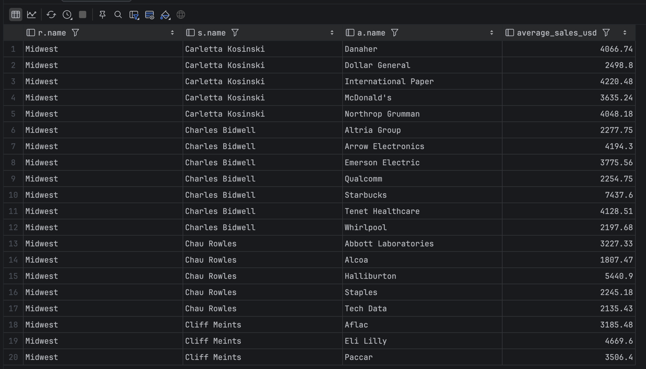
Code:
select distinct r.name,s.name,a.name,
round(avg(o.total_amt_usd) over (partition by r.name,s.name,a.name),2) as average_sales_usd
from region r
join sales_reps s on r.id=s.region_id
join accounts a on s.id =a.sales_rep_id
join orders o on o.account_id = a.id
order by r.name,s.name,a.name
limit 20
Q14: What is the running total of sales by month? Return the first twenty rows
A: 7372719.28
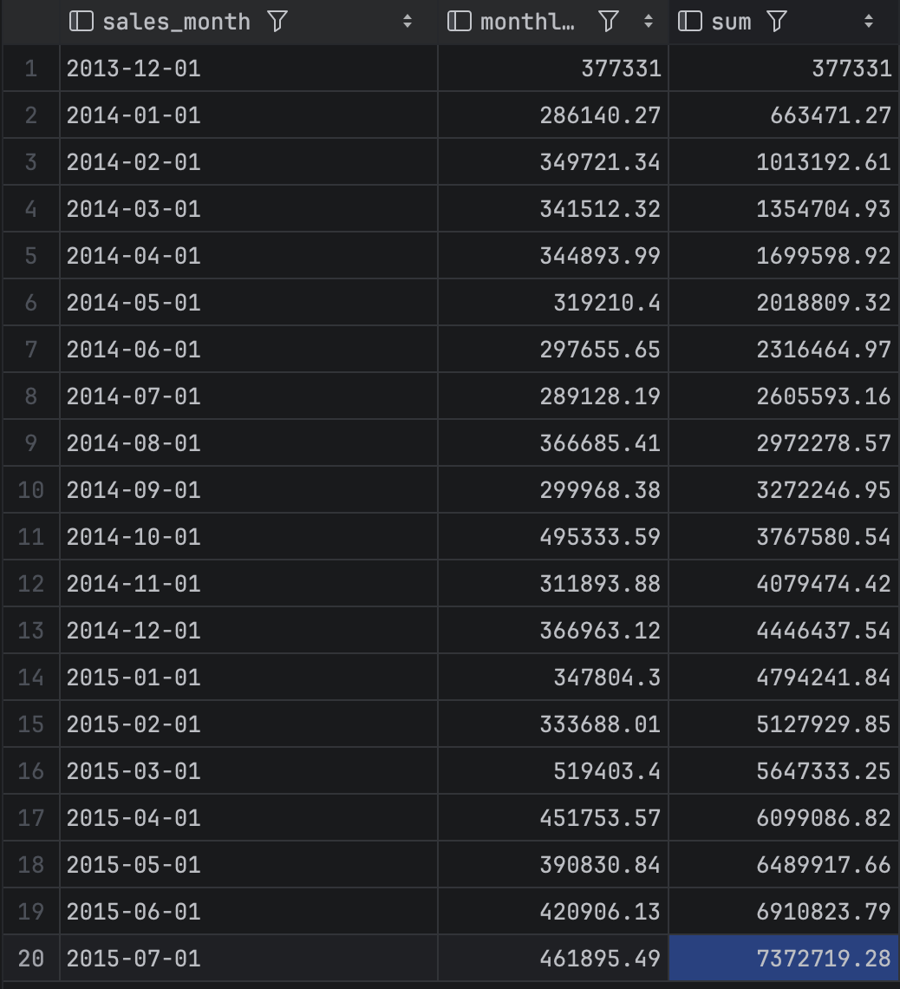
Code:
WITH monthly_sales AS (
select
date_trunc('month',occurred_at)::date as sales_month,
sum(orders.total_amt_usd) as monthly_sales_USD
from orders
group by date_trunc('month',occurred_at)::date
)
select sales_month,monthly_sales_usd,sum(monthly_sales_USD) over (order by sales_month
ROWS BETWEEN UNBOUNDED PRECEDING AND CURRENT ROW)
from monthly_sales
order by sales_month
limit 20
Q15: Create a seven-day moving average of orders (hint: CTE, temp table, or subquery).
A:
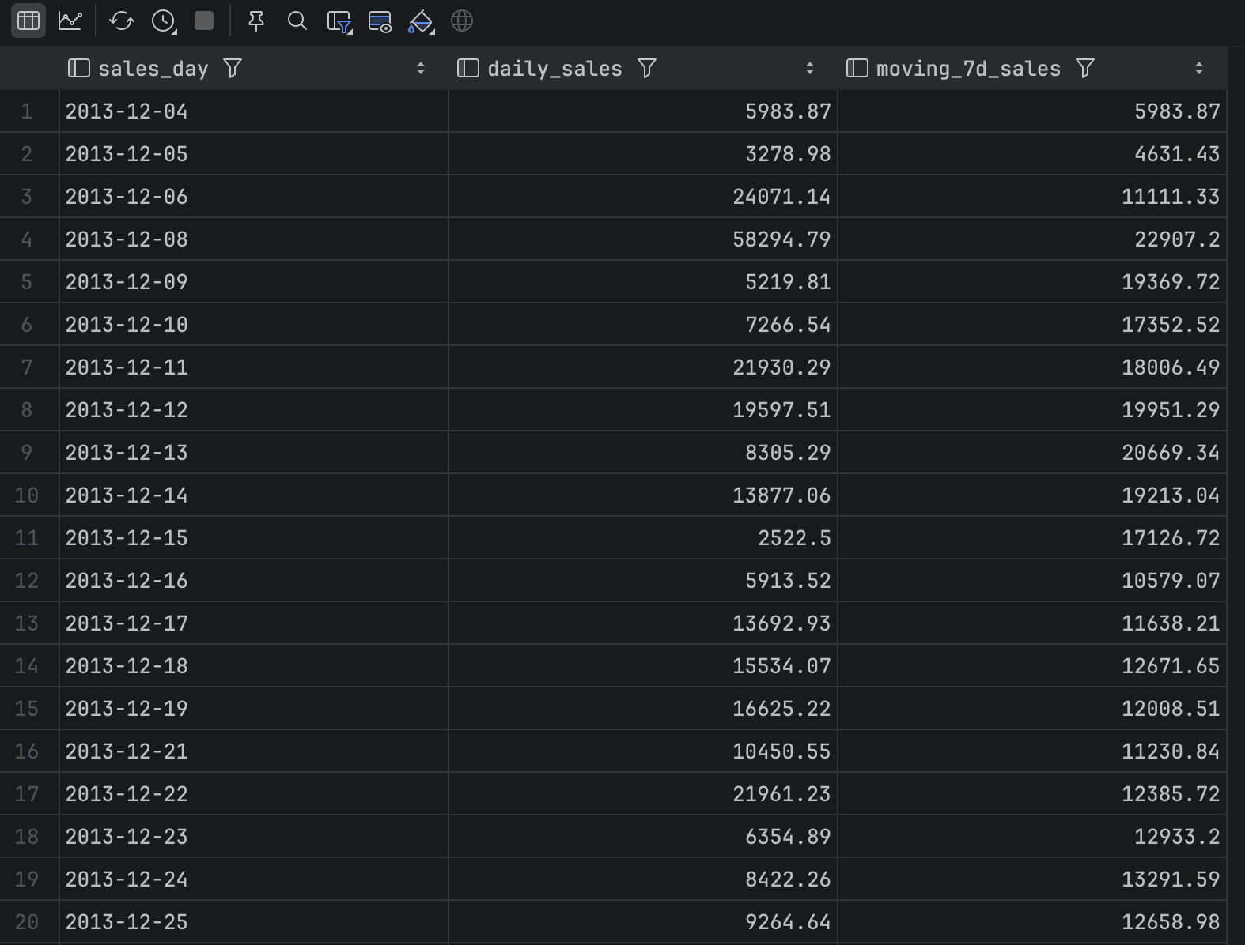
Code:
With Daily_sales AS (
select orders.occurred_at ::date as sales_day, sum(total_amt_usd) as daily_sales
from orders
group by (sales_day)
order by (sales_day)
)
select sales_day,
daily_sales,
round(avg(Daily_sales) over(order by sales_day
range between interval '7 days' preceding and current row),2) as moving_7d_sales
from Daily_sales

